**DBMS LAB: 4.5CA153C01**

**MANAV RACHNA INTERNATIONAL INSTITUTE OF RESEARCH**

**AND STUDIES**

**DEPARTMENT OF COMPUTER APPLICATION**

|  |  |
| --- | --- |
| **SUBMITTED BY** |  |
| Student name | Vanshika |
| Roll No. | 24/SCA/BCA(AI&ML)/071 |
| Programme | BCA(AI&ML) |
| Semester | 1st |
| Section\ Group | B / GROUP-2 |
| Department | SCA |
| Session\ Batch | 2024-2027 |
| **SUBMITTED TO** |  |
| Faculty name | Mrs. Aastha budhiraja |



SCHOOL OF COMPUTER APPLICATIONS

Q1: Create the following tables

STUDENT

**INPUT:**

CREATE TABLE Student (

StudentId NUMBER(4) PRIMARY KEY,

StudentName VARCHAR2(40) NOT NULL,

Address1 VARCHAR2(300),

Gender VARCHAR2(15),

Course VARCHAR2(8)

);

**OUTPUT:**

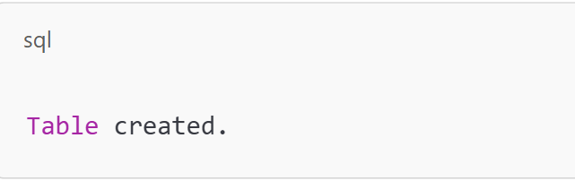

COURSE

**INPUT:**

CREATE TABLE Course (

DeptNo NUMBER(2) PRIMARY KEY,

Dname VARCHAR2(20),

Location VARCHAR2(10)

);

**OUTPUT:**



1. Insert five records for each table.

STUDENT

**INPUT:**

INSERT INTO Student (StudentId, StudentName, Address1, Gender, Course)

VALUES (1, 'John Doe', '123 Main St', 'Male', 'MCA');

INSERT INTO Student (StudentId, StudentName, Address1, Gender, Course)

VALUES (2, 'Jane Smith', '456 Oak St', 'Female', 'BCA');

INSERT INTO Student (StudentId, StudentName, Address1, Gender, Course)

VALUES (3, 'Alice Johnson', '789 Pine St', 'Female', 'MCA');

INSERT INTO Student (StudentId, StudentName, Address1, Gender, Course)

VALUES (4, 'Bob Brown', '101 Maple St', 'Male', 'BCA');

INSERT INTO Student (StudentId, StudentName, Address1, Gender, Course)

VALUES (5, 'Charlie Davis', '202 Birch St', 'Male', 'MCA');

**OUTPUT:**

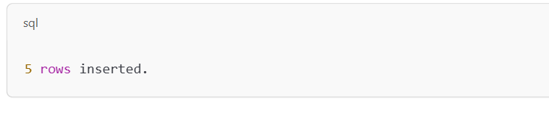

COURSE

**INPUT:**

INSERT INTO Course (DeptNo, Dname, Location)

VALUES (1, 'Computer Science', 'New York');

INSERT INTO Course (DeptNo, Dname, Location)

VALUES (2, 'Electrical Engineering', 'Los Angeles');

INSERT INTO Course (DeptNo, Dname, Location)

VALUES (3, 'Mechanical Engineering', 'Chicago');

INSERT INTO Course (DeptNo, Dname, Location)

VALUES (4, 'Civil Engineering', 'Dallas');

INSERT INTO Course (DeptNo, Dname, Location)

VALUES (5, 'Business Administration', 'Miami');

**OUTPUT**:



1. List all information about all students from student table

**INPUT:**

SELECT * FROM Student;

**OUTPUT:**

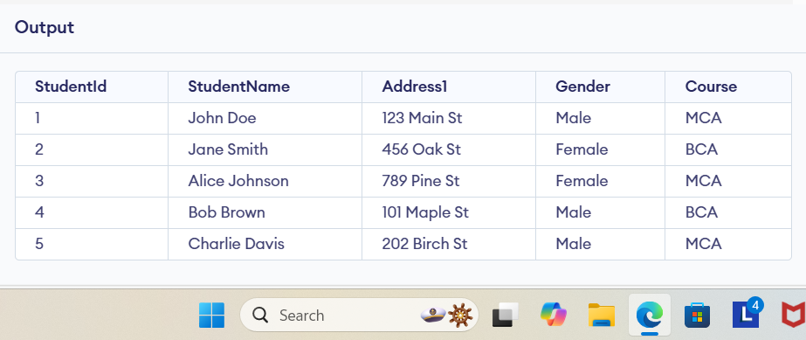

1. List all student numbers along with their Courses.

**INPUT:**

SELECT StudentId, Course FROM Student;

**OUTPUT:**

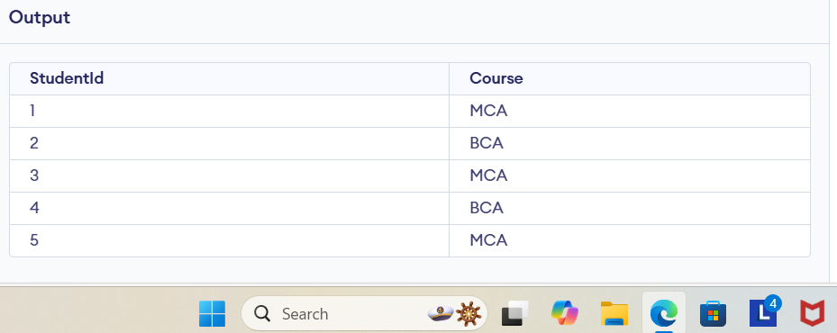

1. List Course names and locations from the Course table

**INPUT:**

SELECT Dname, Location FROM Course;

**OUTPUT:**

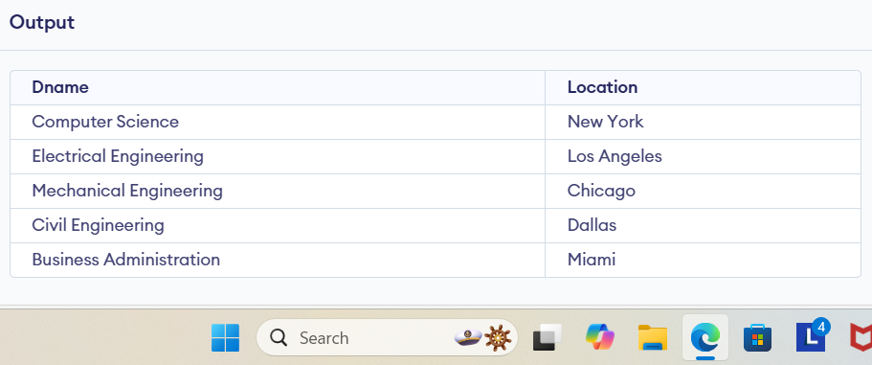

1. List the details of the Students in MCA Course.

**INPUT:**

SELECT * FROM Student WHERE Course = 'MCA';

**OUTPUT:**

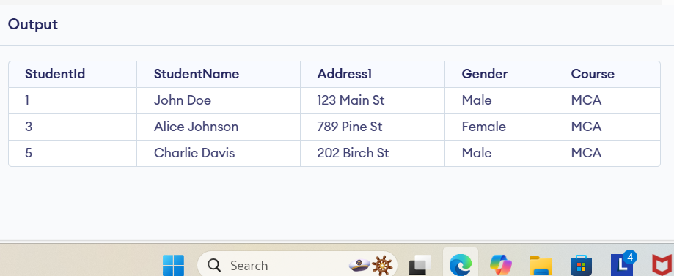

EMPLOYEE TABLE

**INPUT:**

CREATE TABLE Employee (

EmployeeNo NUMBER(4) PRIMARY KEY,

EmployeeName VARCHAR2(40) NOT NULL,

DepartmentNo NUMBER(2),

Salary NUMBER(8, 2),

Commission NUMBER(8, 2)

);

INSERT INTO Employee (EmployeeNo, EmployeeName, DepartmentNo, Salary, Commission)

VALUES (7369, 'John Smith', 10, 5000, 500);

INSERT INTO Employee (EmployeeNo, EmployeeName, DepartmentNo, Salary, Commission)

VALUES (7777, 'Jane Doe', 20, 6000, 600);

INSERT INTO Employee (EmployeeNo, EmployeeName, DepartmentNo, Salary, Commission)

VALUES (2233, 'Alice Brown', 30, 5500, 550);

INSERT INTO Employee (EmployeeNo, EmployeeName, DepartmentNo, Salary, Commission)

VALUES (1111, 'Bob White', 40, 4500, 450);

INSERT INTO Employee (EmployeeNo, EmployeeName, DepartmentNo, Salary, Commission)

VALUES (1001, 'Charlie Davis', 50, 4700, 470);

1. List the names of the employees whose employees numbers are 7369, 7777, 2233

**INPUT:**

SELECT EmployeeName FROM Employee WHERE EmployeeNo IN (7369, 7777, 2233);

**OUTPUT:**

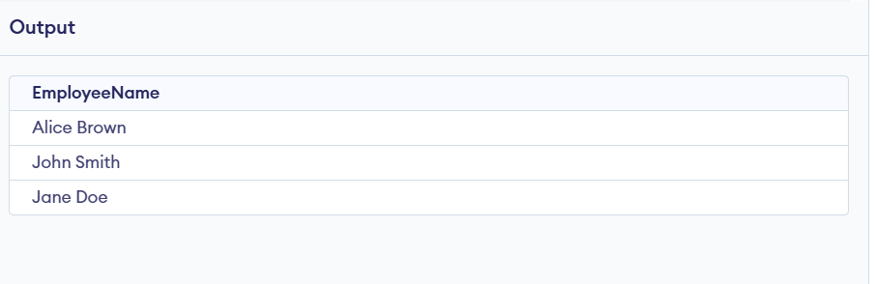

1. List the employee names not belonging to the department 10, 40

**INPUT:**

SELECT EmployeeName FROM Employee WHERE DeptNo NOT IN (10, 40);

1. List the employee names who are not eligible for commission.

**INPUT:**

SELECT EmployeeName

FROM Employee

WHERE Commission IS NULL;

1. List the employees whose names start with “S” not s.

**INPUT:**

SELECT EmployeeName

FROM Employee

WHERE EmployeeName LIKE 'S%';

**OUTPUT:**

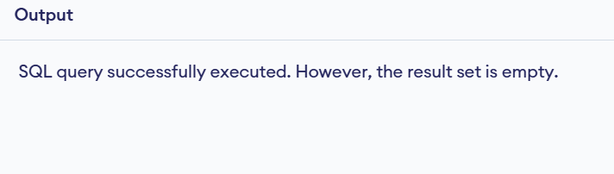

1. List the employees ending with name “s”.

**INPUT:**

SELECT EmployeeName

FROM Employee

WHERE EmployeeName LIKE '%s';

**OUTPUT:**



1. Display all the Arithmetic functions used in SQL.

**INPUT:**

SELECT

5 + 3 AS Add_Operation,

5 - 3 AS Subtract_Operation,

5 * 3 AS Multiply_Operation,

5 / 3 AS Divide_Operation,

(5% 3) AS Modulus_Operation;

**OUTPUT:**

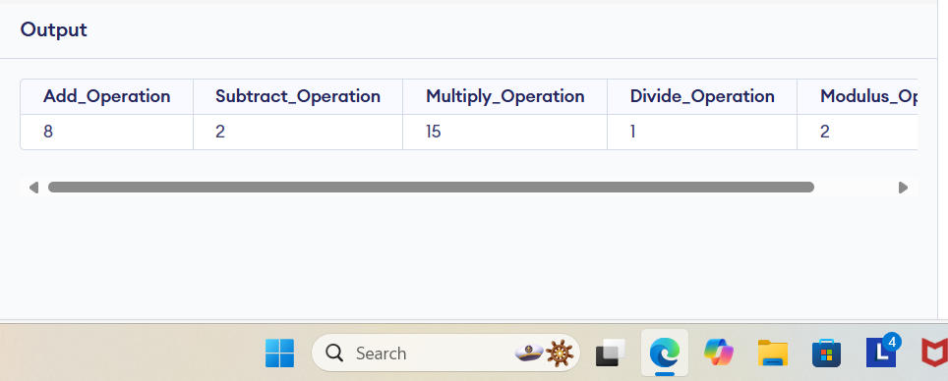

1. List the names, salary and PF amount of all the employees (PF is calculated as 10% of salary)

**INPUT:**

SELECT EmployeeName, Salary, (Salary * 0.10) AS PF_Amount

FROM Employee;

1. List the employee names having “k” as the second character.

**INPUT:**

SELECT EmployeeName

FROM Employee

WHERE EmployeeName LIKE '_k%';

1. List the students not assigned to any department.

**INPUT:**

SELECT * FROM Student WHERE Course IS NULL;

**OUTPUT:**



1. List the students details in ascending order of course

**INPUT:**

SELECT * FROM Student ORDER BY Course ASC;

**OUTPUT:**

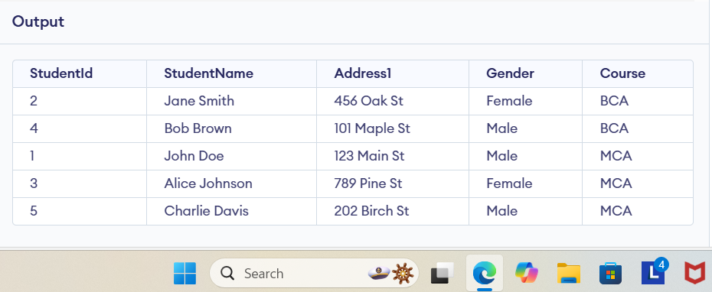

1. List the number of Students in BCA course.

**INPUT:**

SELECT COUNT(*) FROM Student WHERE Course = 'BCA';

**OUTPUT:**

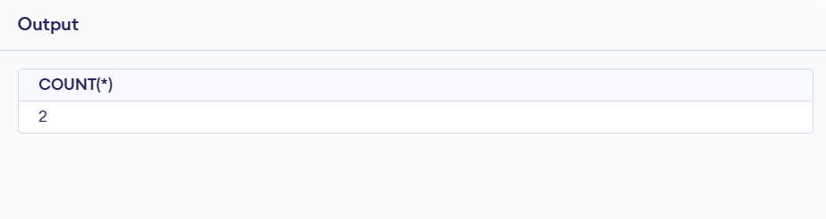

1. List the number of students available in student table.

**INPUT:**

SELECT COUNT(*) FROM Student;

**OUTPUT:**

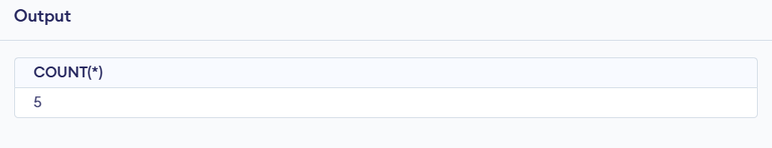

1. Create a table with a primary key constraint.

CREATE TABLE Employee (

EmployeeNo NUMBER(4) PRIMARY KEY,

EmployeeName VARCHAR2(40) NOT NULL,

DepartmentNo NUMBER(2),

Salary NUMBER(8, 2),

Commission NUMBER(8, 2)

);

1. Create a table with all column having not null constraints

CREATE TABLE Student (

StudentId NUMBER(4) PRIMARY KEY,

StudentName VARCHAR2(40) NOT NULL,

Address1 VARCHAR2(300) NOT NULL,

Gender VARCHAR2(15) NOT NULL,

Course VARCHAR2(8) NOT NULL

);

1. Create a foreign key constraint in a table

CREATE TABLE Department (

DeptNo NUMBER(2) PRIMARY KEY,

DeptName VARCHAR2(20)

);

CREATE TABLE Employee (

EmployeeNo NUMBER(4) PRIMARY KEY,

EmployeeName VARCHAR2(40) NOT NULL,

DeptNo NUMBER(2),

FOREIGN KEY (DeptNo) REFERENCES Department(DeptNo)

);

1. Create a Table with a unique key constraint

CREATE TABLE Employee (

EmployeeNo NUMBER(4) PRIMARY KEY,

EmployeeName VARCHAR2(40) NOT NULL,

EmployeeEmail VARCHAR2(100) UNIQUE,

DepartmentNo NUMBER(2)

);

1. Display the different students in department 1 and 2.

**INPUT:**

SELECT * FROM Student

WHERE Course IN ('1', '2');

**OUTPUT:**

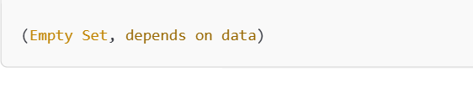

1. Display list of student ordered by course

**INPUT**:

SELECT * FROM Student

ORDER BY Course;

**OUTPUT:**



1. Display alphabetically sorted list of students

**INPUT:**

SELECT *

FROM Student

ORDER BY StudentName;

**OUTPUT:**

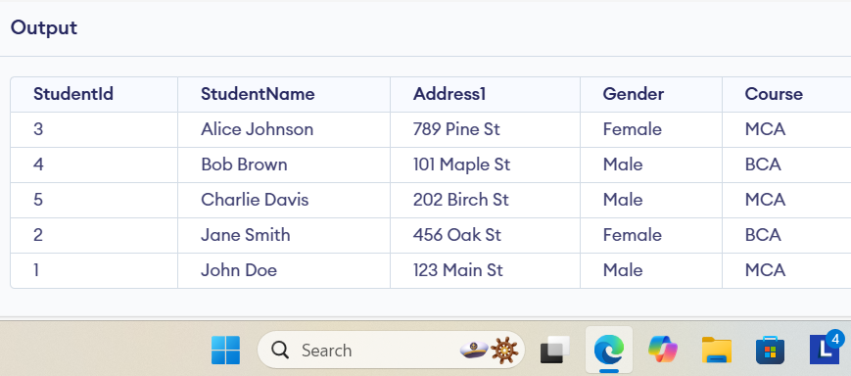

Q2: Create the tables Customer and Orders as per the following:

**INPUT:**

CUSTOMER table

CREATE TABLE CUSTOMER (

SID NUMBER(4) PRIMARY KEY,

Last_Name VARCHAR2(40),

First_Name VARCHAR2(40)

);

ORDERS table

CREATE TABLE ORDERS (

Order_ID NUMBER(4) PRIMARY KEY,

Order_Date DATE,

Customer_SID NUMBER(4),

Amount NUMBER(10,2),

CONSTRAINT fk_customer FOREIGN KEY (Customer_SID) REFERENCES CUSTOMER(SID),

CONSTRAINT check_amount CHECK (Amount > 20000)

);

**OUTPUT:**

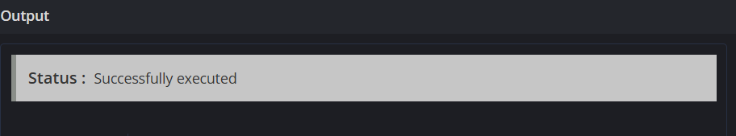

1. Insert five records for each table

**INPUT:**

CUSTOMER table

INSERT INTO CUSTOMER (SID, Last_Name, First_Name) VALUES (1, 'Smith', 'John');

INSERT INTO CUSTOMER (SID, Last_Name, First_Name) VALUES (2, 'Doe', 'Jane');

INSERT INTO CUSTOMER (SID, Last_Name, First_Name) VALUES (3, 'Brown', 'Charlie');

INSERT INTO CUSTOMER (SID, Last_Name, First_Name) VALUES (4, 'Johnson', 'Alice');

INSERT INTO CUSTOMER (SID, Last_Name, First_Name) VALUES (5, 'Williams', 'David');

ORDERS table

INSERT INTO ORDERS (Order_ID, Order_Date, Customer_SID, Amount) VALUES (101, '2024-01-01', 1, 25000);

INSERT INTO ORDERS (Order_ID, Order_Date, Customer_SID, Amount) VALUES (102, '2024-02-15', 2, 30000);

INSERT INTO ORDERS (Order_ID, Order_Date, Customer_SID, Amount) VALUES (103, '2024-03-10', 3, 22000);

INSERT INTO ORDERS (Order_ID, Order_Date, Customer_SID, Amount) VALUES (104, '2024-04-05', 4, 25000);

INSERT INTO ORDERS (Order_ID, Order_Date, Customer_SID, Amount) VALUES (105, '2024-05-20',5, 21000);

**OUTPUT:**

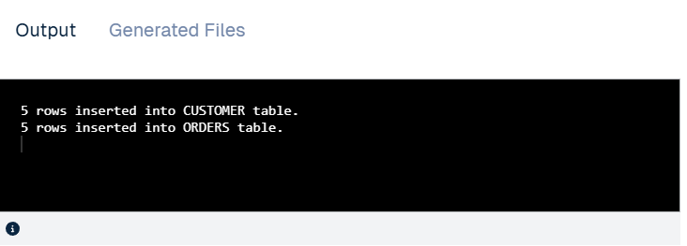

1. The Customer_SID column in the ORDERS table is a foreign key pointing to the SID column in the CUSTOMER table.

**INPUT:**

CUSTOMER table

CREATE TABLE CUSTOMER (

SID NUMBER(4) PRIMARY KEY,

Last_Name VARCHAR2(40),

First_Name VARCHAR2(40)

);

ORDERS table with the foreign key constraint

CREATE TABLE ORDERS (

Order_ID NUMBER(4) PRIMARY KEY,

Order_Date DATE,

Customer_SID NUMBER(4),

Amount NUMBER(10,2),

CONSTRAINT fk_customer FOREIGN KEY (Customer_SID) REFERENCES CUSTOMER(SID),

CONSTRAINT check_amount CHECK (Amount > 20000)

);

1. List the details of the customers along with the amount.

**INPUT:**

SELECT c.SID, c.Last_Name, c.First_Name, o.Amount

FROM CUSTOMER c

JOIN ORDERS o ON c.SID = o.Customer_SID;

**OUTPUT:**

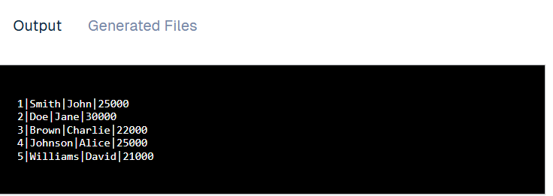

1. List the customers whose names end with “s”.

**INPUT:**

SELECT *

FROM CUSTOMER

WHERE Last_Name LIKE '%s';

**OUTPUT:**

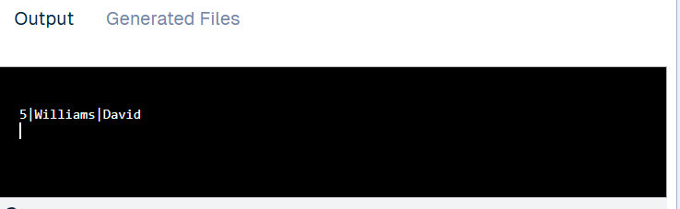

1. List the orders where amount is between 21000 and 30000

**INPUT:**

SELECT *

FROM ORDERS

WHERE Amount BETWEEN 21000 AND 30000;

**OUTPUT:**

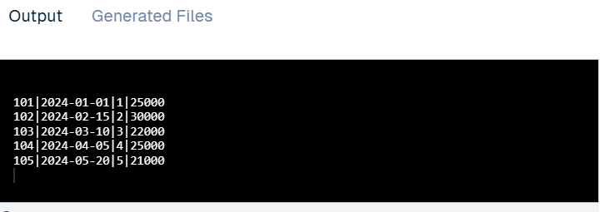

1. List the orders where amount is increased by 500 and replace with name “new amount”.

**INPUT:**

SELECT Order_ID, Amount + 500 AS "new amount"

FROM ORDERS;

**OUTPUT:**

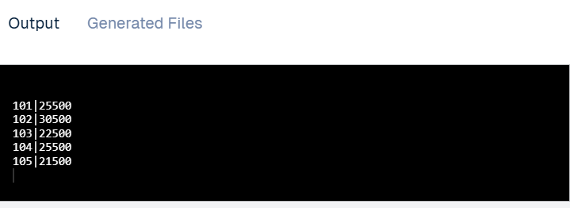

1. Display the order_id and total amount of orders

**INPUT:**

SELECT Order_ID, Amount

FROM ORDERS;

**OUTPUT:**

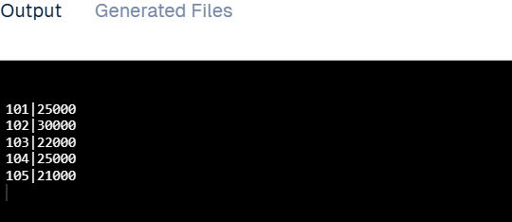

1. Calculate the total amount of orders that has more than 15000.

**INPUT:**

SELECT SUM(Amount) AS Total_Amount

FROM ORDERS

WHERE Amount > 15000;

**OUTPUT:**

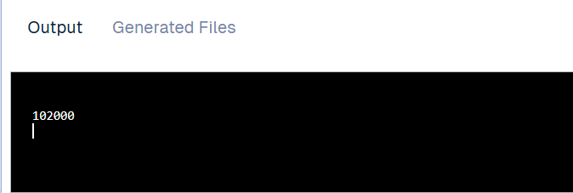

1. Display all the contents of s4 and s5 using union clause.

**INPUT:**

SELECT * FROM S4

UNION

SELECT * FROM S5;

1. Find out the intersection of s4 and s5 tables.

SELECT * FROM S4

INTERSECT

SELECT * FROM S5;

1. Display the names of s4 and s5 tables using left, right, inner and full join.

-- Left Join

SELECT *

FROM S4

LEFT JOIN S5 ON S4.id = S5.id;

-- Right Join

SELECT *

FROM S4

RIGHT JOIN S5 ON S4.id = S5.id;

-- Inner Join

SELECT *

FROM S4

INNER JOIN S5 ON S4.id = S5.id;

-- Full Join

SELECT *

FROM S4

FULL JOIN S5 ON S4.id = S5.id;

1. Display the first name of employee and their managers using self-join.

**INPUT:**

SELECT e.First_Name AS Employee_Name, m.First_Name AS Manager_Name

FROM Employee e

LEFT JOIN Employee m ON e.Manager_ID = m.EmployeeNo:

1. Find out the names of s4 which are distinct

SELECT DISTINCT * FROM S4;

1. Write a query to Grant access and modification rights to customer table to user

**INPUT:**

GRANT SELECT, INSERT, UPDATE, DELETE ON CUSTOMER TO user_name;

**OUTPUT:**



1. Write a query to revoke access rights to customer table to user

CUSTOMER table

REVOKE SELECT, INSERT, UPDATE, DELETE ON CUSTOMER FROM username;

1. Write a query to take backup of a database

exp username/password@database full=y file=full_db_backup.dmp log=backup_log.txt

USING RMAN (PHYSICAL BACKUP)

rman target /

BACKUP DATABASE;

1. Write a query to restore a database

rman target /

RESTORE DATABASE;